Experiment 8

Aim
Implement Intermediate Code Generation using LEX and YACC

Theory

Need for Intermediate Code Generation (ICG):
Abstraction: Intermediate code provides a level of abstraction between the high-level source code and the low-level machine code. This abstraction simplifies the complexity of the compilation process by breaking it down into smaller, more manageable steps.
Portability: By generating an intermediate representation that is independent of the target machine architecture, compilers can produce executable code that can run on different platforms without modification.
Optimization: Intermediate code serves as a platform for applying optimization techniques such as constant folding, common subexpression elimination, and loop optimization. These optimizations can significantly improve the performance of the generated code.
Simplification: Analyzing and transforming the source code directly can be challenging due to its complexity and variability. Intermediate code provides a standardized representation that facilitates analysis and transformations.

Different Types of ICG:
Syntax Trees Syntax trees represent the hierarchical syntactic structure of the source code. Each node in the tree corresponds to a syntactic construct, and the children of a node represent its sub-constructs.
Postfix Notation Postfix notation, also known as Reverse Polish Notation (RPN), represents expressions in a linear format where each operator follows its operands. This notation simplifies expression evaluation and code generation.
Three Address Code: Three address code represents instructions with at most three operands, typically in the form of “destination = source1 operator source2.” It provides a simple yet expressive representation that is easy to manipulate during code generation and optimization.
Quadruples: Quadruples extend three-address code by including a serial number for each instruction. Each quadruple consists of four fields: operator, operand1, operand2, and result. Quadruples facilitate code optimization and analysis by providing a structured representation of
executable instructions.

Three Address Code Representations with Examples
Example 1: Consider the assignment statement a = b + c.
T1 = b + c
a = T1 Here, T1 is a temporary variable used to hold the result of the addition operation before assigning it to a.

Example 2: For a conditional statement if (a < b) goto L1 else goto L2, the corresponding
three-address code can be:
if a < b goto L1
goto L2 This code redirects control flow based on the comparison result.

Syntax Directed Translation (SDT) and Its Types:
Definition: Syntax-directed translation associates semantic actions with productions in a context-free grammar. These actions are triggered during parsing and enable the generation of intermediate code or other transformations.
Types:
- S-attributed SDT: In S-attributed SDT, attributes are synthesized using only information from the children of a node in the parse tree. The values of attributes are computed bottom-up during parsing.
- L-attributed SDT: L-attributed SDT allows attributes to depend on both inherited and synthesized attributes. It supports more complex attribute dependencies and enables a broader range of semantic analysis and transformations.

SDT for Converting Binary Number to Decimal:
Production Rule:
BinaryNum → BinaryDigit | BinaryNum BinaryDigit
BinaryDigit → 0 {value = 0} | 1 {value = 1}

Semantic Actions:

BinaryNum.value = BinaryNum.value * 2 + BinaryDigit.value

Here, BinaryNum.value represents the decimal value of the binary number, and
BinaryDigit.value represents the decimal value of each binary digit.

Syntax Directed Translation for Generating Three Address Code and Quadruples:
Production Rule:

Expr → Expr + Term
Expr.code = Expr.code || Term.code || "t" || t = Expr.place + Term.place

Explanation: This rule generates three-address code for addition operation where Expr represents an expression, Term represents a term, Expr.code stores the generated code for the expression, Term.code stores the generated code for the term, t is a temporary variable, and Expr.place and Term.place represents the addresses of the expression and term, respectively.

Quadruples Generation:
1. t1 = Expr.place
2. t2 = Term.place
3. t3 = t1 + t2
These quadruples represent the addition operation where t1 and t2 hold the values of the expression and term, respectively, and t3 stores the result of the addition operation

Code

Filename : icg.l:
%{
#include"y.tab.h"
%}
%%
[a-zA-Z]+ {strcpy(yylval.str,yytext); return Var;}
[0-9]+ {strcpy(yylval.str,yytext); return Num;}
\n {return 0;}
[\t] {}
. {return yytext[0];}
%%
int yywrap()
{
return 1;
}

Filename : icg.y:
%{
#include<stdio.h>
#include<stdlib.h>
#include<string.h>
char * createT(); // Declaration for creating the temporary
variables
int tempcount=0; // Global variable to track the number of
temporary varaiables
%}
%union { char str[30]; }

int by default
%left '+'
%left '-'
%left '*'
%left '/'
%token <str> Var // Defining the datatype of Tokens as str
%token <str> Num
%type <str> s // Defining the datatypes of Non-Terminals
%type <str> exp

%%
s : Var '=' exp {printf("\n%s=%s\n",$1,$3);}
exp : '(' exp ')' {strcpy($$,$2);}
| exp '+' exp {strcpy($$ ,createT());
printf("\n%s=%s+%s",$$,$1,$3);}
| exp '-' exp {strcpy($$ ,createT());
printf("\n%s=%s-%s",$$,$1,$3);}
| exp '*' exp {strcpy($$ , createT());
printf("\n%s=%s*%s",$$,$1,$3);}
| exp '/' exp {strcpy($$ , createT());
printf("\n%s=%s/%s",$$,$1,$3);}
| Num {strcpy($$,$1);}
| Var {strcpy($$, $1);}
;
%%

char * createT()
{
// Declaring the string array and pointer variable
char snum[30],*ptr;

sprintf(snum,"t%d",tempcount);
ptr=snum; // Intializing the pointer with formatted string
tempcount++; // Temporary count
return ptr; // Returning the pointer
}

int main()
{
yyparse();
return 0;
}
int yyerror(char *err)
{
printf("\nInvlaid");
exit(0);
}
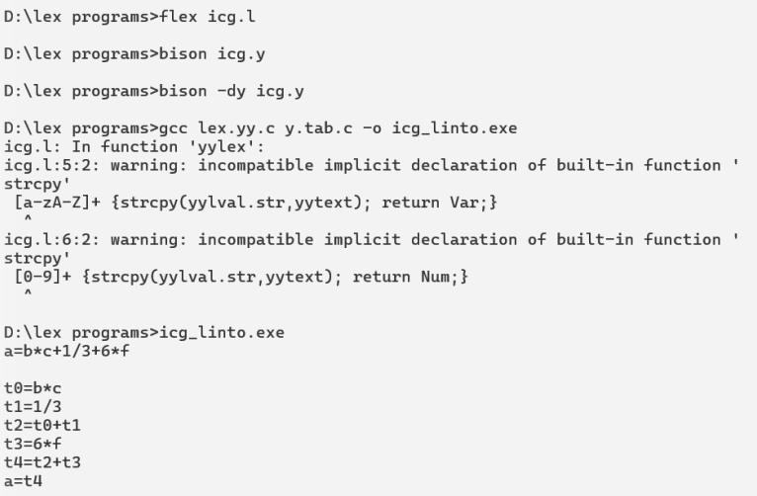

Filename : quad.y
%{
#include<stdio.h>
#include<stdlib.h>
#include<string.h>
char * createT(); // Declaration for creating the temporary
variables
int tempcount=0; // Global variable to track the number of
temporary varaiables
%}
%union { char str[30]; }
// Redefining the datatype of yylval using union
declaration, which is int by default
%left '+'
%left '-'
%left '*'
%left '/'
%token <str> Var // Defining the datatype of Tokens as str
%token <str> Num
%type <str> s // Defining the datatypes of Non-Terminals
%type <str> exp
%%
s : Var '=' exp {printf("\n = %s %s\n",$3,$1);}
exp : '(' exp ')' {strcpy($$,$2);}
| exp '+' exp {strcpy($$ ,createT()); printf("\n + %s
%s %s ",$1,$3,$$);}
| exp '-' exp {strcpy($$ ,createT()); printf("\n - %s
%s %s",$1,$3,$$);}
| exp '*' exp {strcpy($$ , createT()); printf("\n * %s
%s %s",$1,$3,$$);}
| exp '/' exp {strcpy($$ , createT()); printf("\n / %s
%s %s",$1,$3,$$);}
| Num {strcpy($$,$1);}
| Var {strcpy($$, $1);}
;
%%
char * createT()
{
char snum[30],*ptr; // Declaring the string array and
pointer variable
sprintf(snum,"t%d",tempcount); // Returning a formatted
String
ptr=snum; // Intializing the pointer with formatted string
tempcount++; // Temporary count
return ptr; // Returning the pointer
}
int main()
{
yyparse();
return 0;
}
int yyerror(char *err)
{
printf("\nInvlaid");
exit(0);

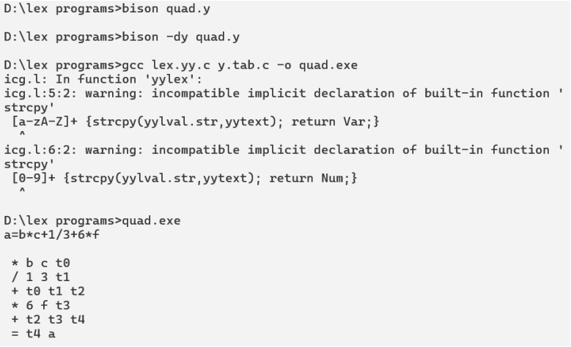

Conclusion:

In conclusion, the implementation of Yacc in C for parsing source code effectively showcased the pivotal role of Yacc in compiler design. The program adeptly tackled a range of tasks including parsing arithmetic expressions for a simple calculator, recognizing nested IF statements and determining their levels, and identifying valid variables in C language syntax. By successfully handling these tasks, the Yacc program underscored the significance of Yacc in facilitating syntactic analysis and code generation within the compilation process. Just as Lex is essential for lexical analysis, Yacc's contribution in parsing and syntax analysis is paramount, solidifying its indispensable role in the comprehensive compilation workflow.

